Radiated Emission Test Report

Contents

1. Test lab facility 2

Test Site: 2

Facility name: 2

Facility address: 2

Facility site description: 2

Test Standards 2

EMC Directive 2014/30/EU 2

Test Equipment: 2

Environmental conditions: 3

Test Operator and Date: 3

2. Product Information 3

3. EUT setup 3

Photograph of EUT: 3

4. Test Result 4

5. Summary 8

# Test lab facility

## Test Site:

Facility name: Keysight Technology, Technology Order Fulfillment, Colorado Springs Hardware Test Center.

Facility address: 1900 Garden of the Gods Rd, Colorado Springs, CO. 80907

Facility site description:

3 Meter Semi-echoic chamber.

Note: *The radiated RF disturbance measurements were performed on an alternate test site of a semi–anechoic chamber at a 3 m distance. The 3 m test distance on an alternate test site is allowed because the EUT met the definition of small equipment in clause 3.10 and per clause 8.4 of CISPR 11:2009+A1:2010. The alternate test site semi–anechoic chamber meets the volumetric NSA validation requirements in CISPR 16–1–4 for the ±–4 dB from theoretical at all positions and antenna polarizations in the test volume*. *The limit for 10 meter site is adjusted by 10dB to fit 3 meter site.*

## Test Standards

### EMC Directive 2014/30/EU

IEC 61326-1:2012 / EN 61326-1:2013 (Basic) Radiated Emission Reference Standards:

CISPR 11:2009+A1:2010 / EN 55011:2009+A1:2010 Group 1 Class A. The products were tested in a typical configuration with Keysight Technologies test systems. This product is intended for use in a basic electromagnetic environment.

## Test Equipment:

|  |  |
| --- | --- |
| MXE Receiver Address | USB0::0x0957::0x0f0b::MY51210168::0::INSTR |
| Turn Table Address | gpib8 |
| Antenna Address | gpib9 |
| MXE Model S/N | MXE N9038A MY51210168 |
| MXE Calibration date | 12/8/2016 |
| Turntable SN | ETS Lindrgen Model 2090 MY70235245 |
| Turn Table calibration date | 12/1/2016 |
| Antenna SN | ETS Lindrgen Model 3142E |
| Antenna calibration date | 12/1/2016 |
| System loss calibration date | 4/1/2016 |
| NSA calibration date | 12/1/2016 |
| Test Standard | CISPER 11 Group 1 Class A RE |
| Test Site | Colorado Springs TOF Hardware Test Center 3 Meter anechoic chamber |
| Test Voltage | 110V |

## Environmental conditions:

Temperature: 72°F; Humidity :50 RH

Note: There will be no effect to the result due to changes in mains voltage or frequency.

## Test Operator and Date:

Operator: Clifford; Report generated at: Sep.20,2017 9:21:17 AM

# Product Information

|  |  |
| --- | --- |
| Product Name: | test |
| Product Model: | DSOX1002G |
| Product SN: | CN57326232 |
| Project Stage: | FPR |
| Deliver date of the test samples: | 8/22//2017 |
| DUT power: | 110V |
| Auxiliary equipment list: | USB BNC cables |
| Model numbers covered by the test: | N/a |
| .-Hardware Difference | N/a |
| .-Software/firmware difference: | N/a |
| .-Cosmetic difference: | NA |
| Test Configuration | add copper tape on the front USB to chassis |

# EUT setup

## Photograph of EUT:

# Test Result

|  |  |  |  |  |  |  |  |  |  |  |
| --- | --- | --- | --- | --- | --- | --- | --- | --- | --- | --- |
| Frequency (Hz) | Amplitude (dBuV) | Turn Table (degree) | Antenna Height (cm) | Polaritzation | QuasiPeak (dBuV) | Peak (dBuV) | Avg (dBuV) | DeltQ (dB) | DeltP (dB) | DeltA (dB) |
| 149994952.0 | 50.0 | 57.0 | 176.0 | Horizontal | 48.4 | 48.7 | 47.8 | -1.6 | -1.3 | -2.2 |
| 290000724.0 | 55.3 | 80.0 | 150.0 | Horizontal | 54.6 | 54.9 | 53.6 | -2.4 | -2.1 | -3.4 |
| 515000000.0 | 59.3 | 8.0 | 160.0 | Horizontal | 59.3 | 59.5 | 59.0 | 2.3 | 2.5 | 2.0 |

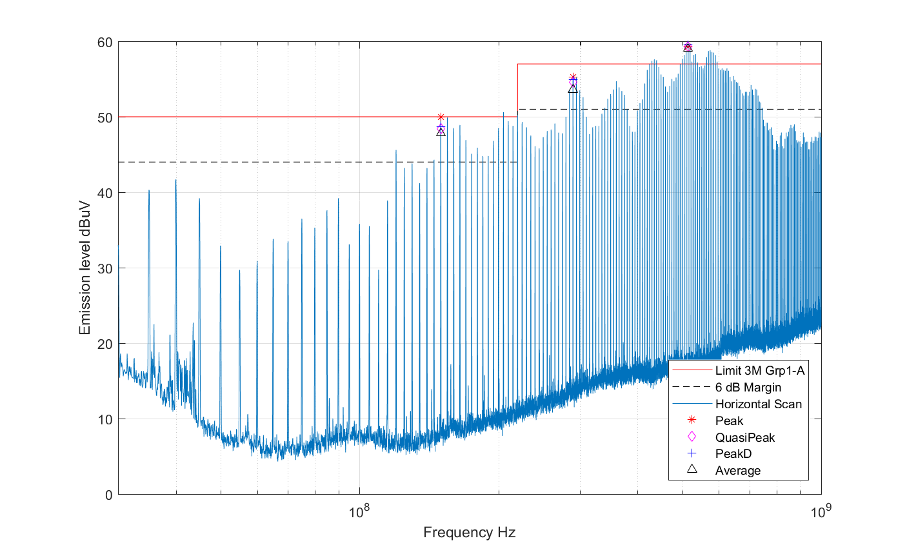

|  |  |  |  |  |  |  |  |  |  |  |
| --- | --- | --- | --- | --- | --- | --- | --- | --- | --- | --- |
| Frequency (Hz) | Amplitude (dBuV) | Turn Table (degree) | Antenna Height (cm) | Polaritzation | QuasiPeak (dBuV) | Peak (dBuV) | Avg (dBuV) | DeltQ (dB) | DeltP (dB) | DeltA (dB) |
| 119998714.0 | 52.6 | 320.0 | 170.0 | Vertical | 47.5 | 47.6 | 47.0 | -2.5 | -2.4 | -3.0 |
| 290005724.0 | 59.8 | 247.0 | 150.0 | Vertical | 59.2 | 59.3 | 58.8 | 2.2 | 2.3 | 1.8 |
| 475003355.0 | 68.3 | 251.0 | 151.0 | Vertical | 67.4 | 67.5 | 67.2 | 10.4 | 10.5 | 10.2 |
| 875004848.0 | 60.0 | 137.0 | 168.0 | Vertical | 55.9 | 56.2 | 55.6 | -1.1 | -0.8 | -1.4 |
| 995004795.0 | 60.2 | 289.0 | 153.0 | Vertical | 56.8 | 57.0 | 56.5 | -0.2 | 0.0 | -0.5 |

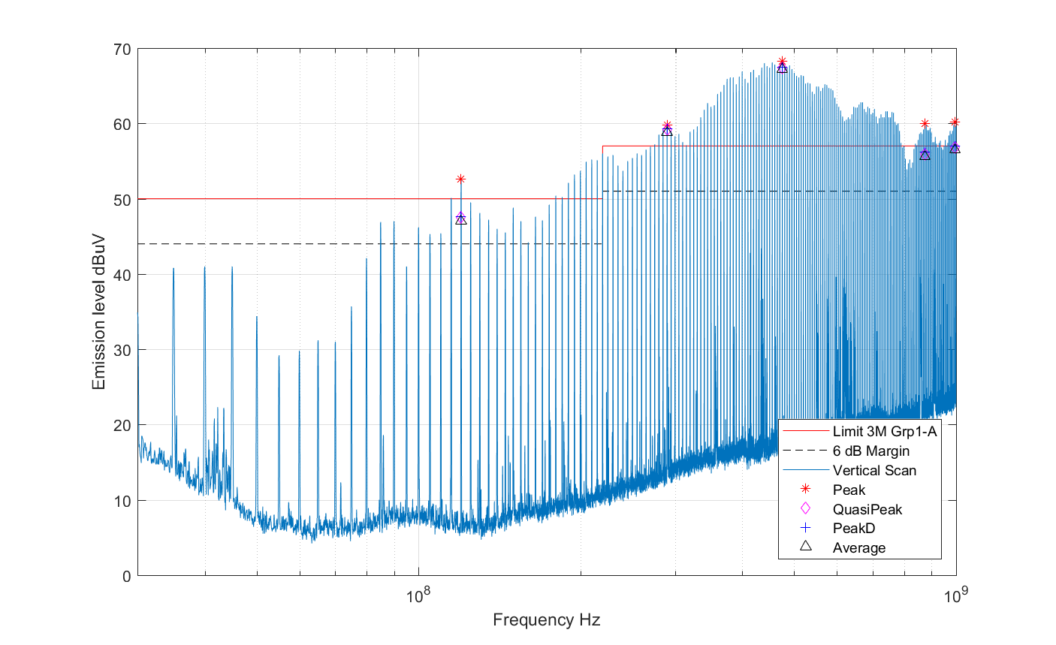

# Summary

The unit FAILED the Radiated Emission Test in Horizontal polarization!

The unit FAILED the Radiated Emission Test in Vertical polarization!